Please Pray for …

Sacred Heart Cathedral
2023-2024 First Communion Class

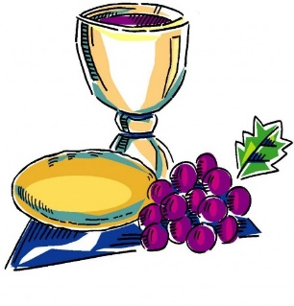

Rowan Beals
Marley Foutch
Eric Le
Cora Lehman
Eric Tran Nguyen
Eve Ruiz
Easton Slesicki
John Paul Van Straten
*Asher Collins
*Caleb Collins
*Norah Keppy
*May McClinton
*Laya Teague

*Students who are receiving the Sacraments of Initiation at the Easter Vigil on Saturday, March 30th, however they will be participating in the First Communion Retreat (Saturday, April 13th) and the First Communion Mass (Sunday, May 5th).

If you would like to write any student a card or a short letter please do so by Friday, April 12th. The student’s name should be clearly written on the envelope. Students will receive these during their First Communion Retreat on Saturday, April 13th.

All cards and letters can be dropped off to the Parish Office or placed in the collection basket. Please write on them, “First Communion Cards” attention Mrs. Susan Stanforth.

Questions?
Susan Stanforth; Faith Formation
davsacredheartdre@diodav.org
Cell: 563-726-3852

